**Report**

**Project Title:**

Fraud Classification Using Machine Learning.

**Team Leader:**

Ejumalla Saikiran

**Team members:**

1.Naveen

2.Sindhuja

3.Bhavya

4.Lakshanya

5.Nanda

**Data Analysis on the fraud classification model:**

Based on the provided data and the output from the fraud detection model, here's a report summarizing the findings:

Fraud Detection Report:

**Transaction 1:**

Account Age: 29 days

Number of Items: 1

Local Time: 4.75 AM

Payment Method: PayPal

Payment Method Age: 28.20 days

Probability of Fraud: 0.03297 (3.30%)

**Transaction 2:**

Account Age: 725 days

Number of Items: 1

Local Time: 4.74 AM

Payment Method: Store Credit

Payment Method Age: 0 days

Probability of Fraud: 0.00063 (0.06%)

**Transaction 3:**

Account Age: 845 days

Number of Items: 1

Local Time: 4.92 AM

Payment Method: Credit Card

Payment Method Age: 0 days

Probability of Fraud: 0.00040 (0.04%)

**Transaction 4:**

Account Age: 503 days

Number of Items: 1

Local Time: 4.89 AM

Payment Method: Credit Card

Payment Method Age: 0 days

Probability of Fraud: 0.00266 (0.27%)

**Transaction 5:**

Account Age: 2000 days

Number of Items: 1

Local Time: 5.04 AM

Payment Method: Credit Card

Payment Method Age: 0 days

Probability of Fraud: 0.00000 (0.000063%)

**Observations:**

Transaction 1 has the highest probability of fraud at 3.30%, possibly due to the relatively young account age and the payment method being PayPal.

Transactions 2, 3, 4, and 5 have very low probabilities of fraud, ranging from 0.06% to 0.27%.

It appears that transactions with credit cards and older account ages tend to have lower probabilities of fraud.

**Output Screen shots:**

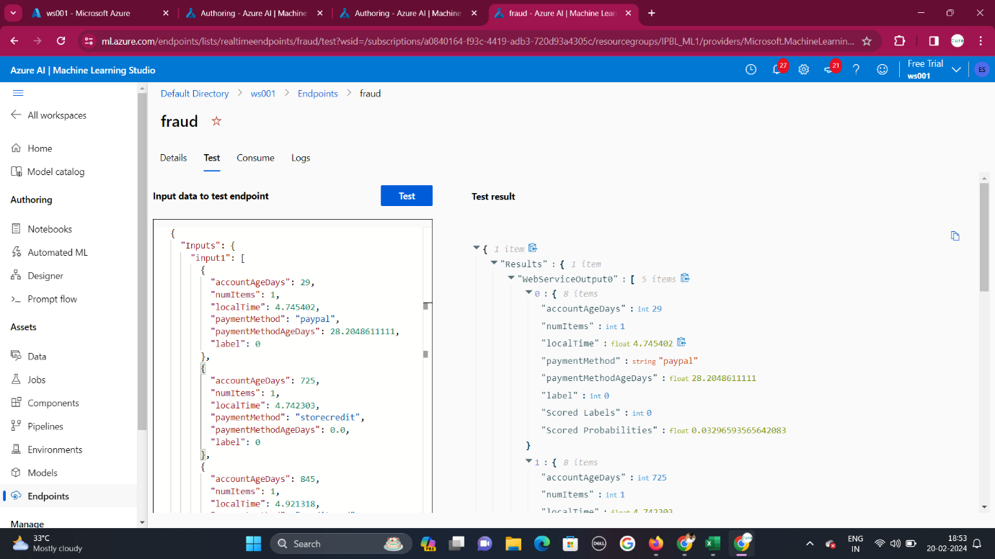

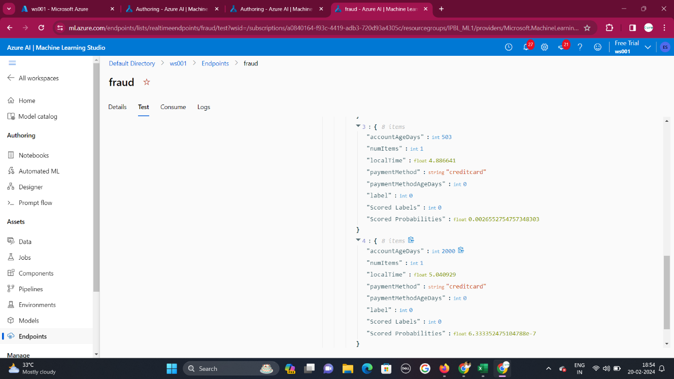

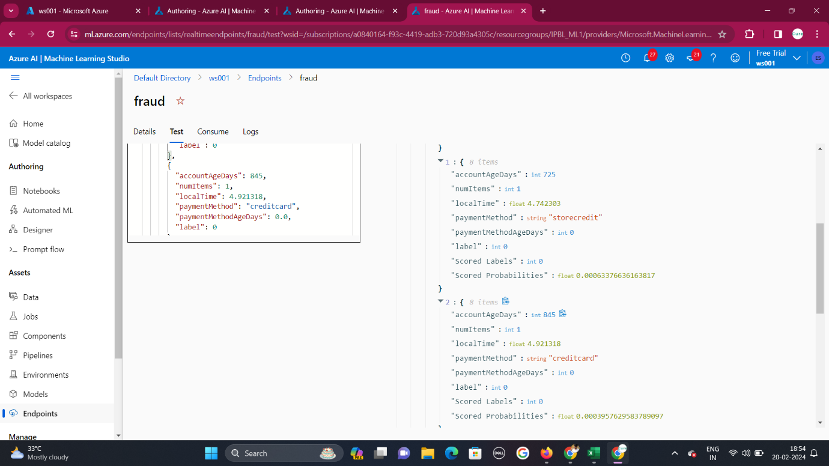

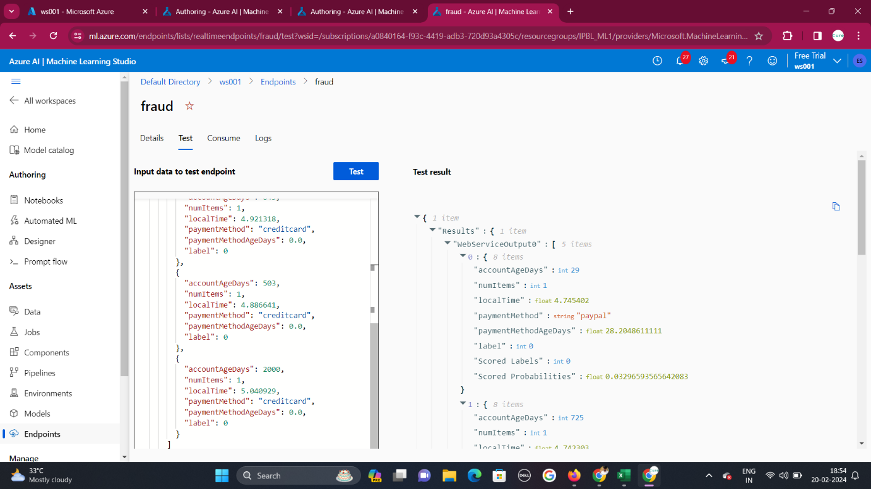

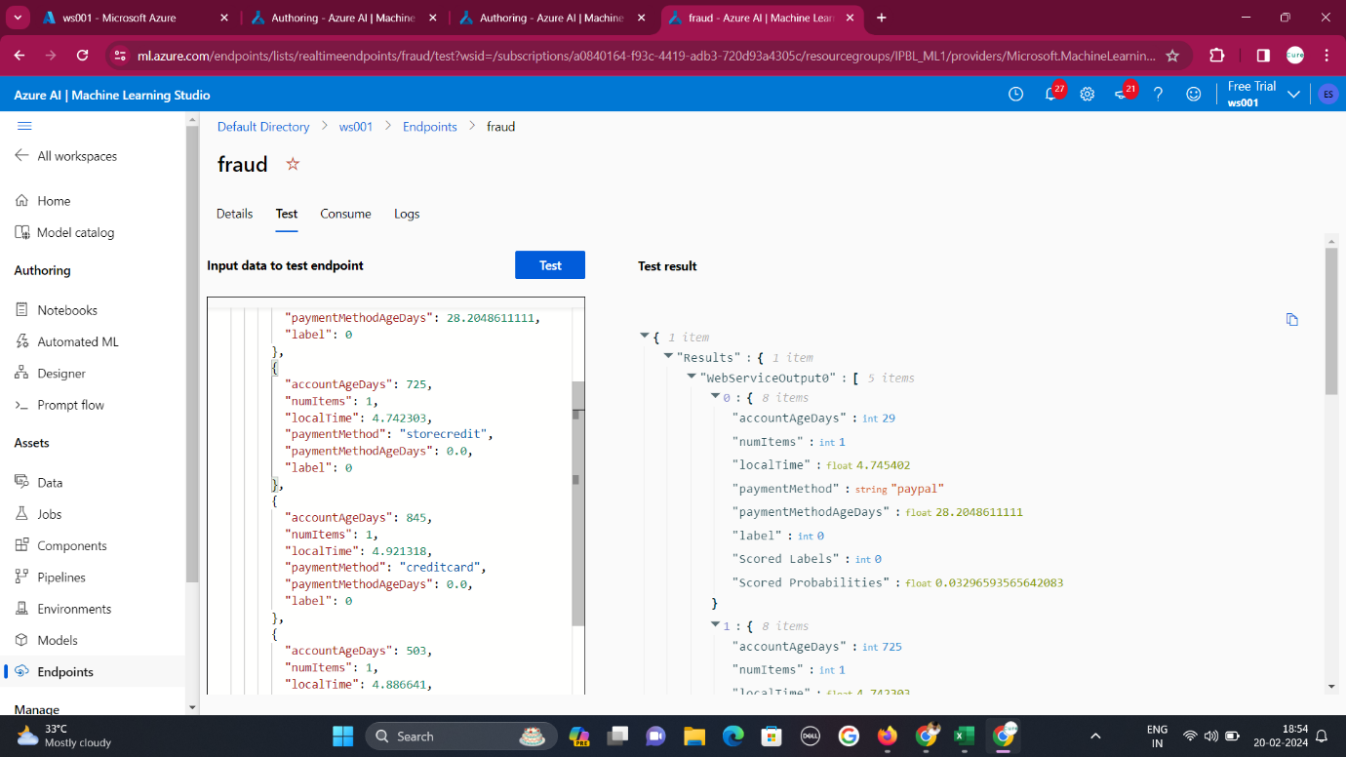

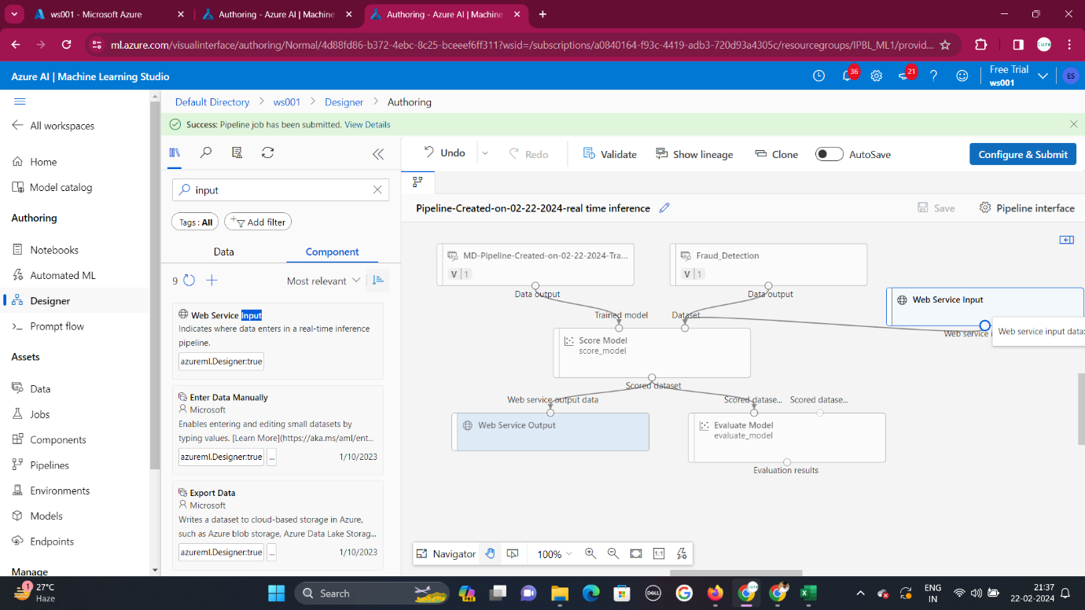

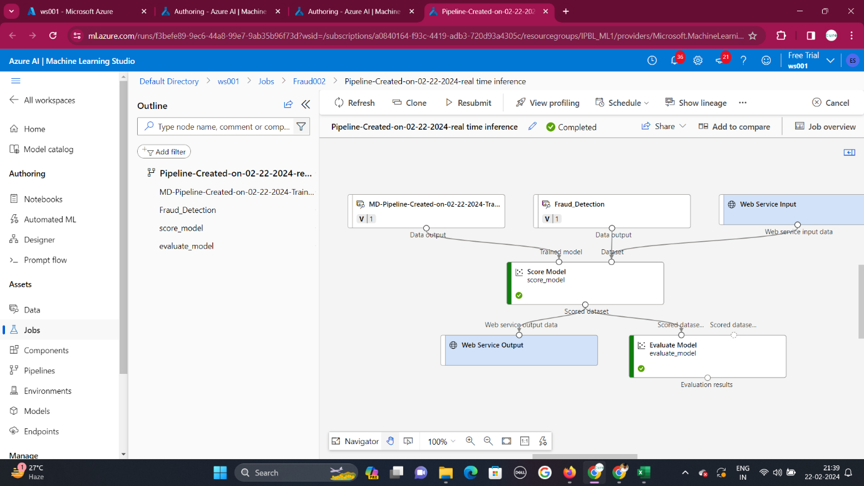

**Conclusion:**

* Transactions 2, 3, and 5 seem legitimate, with very low probabilities of fraud.
* Transaction 4 has a slightly elevated probability of fraud but is still relatively low.
* Transaction 1 raises more suspicion due to the higher probability of fraud, relatively new account, and transaction occurring at an unusual time. It may warrant further investigation.